**Learning Journey Overview**

***Year 2***

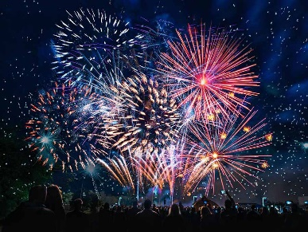

***Learning Journey Focus:***

*Poetry*

|  |  |  |  |  |
| --- | --- | --- | --- | --- |
| **Key Outcomes of the Learning Journey** | **Target** | **Some** | **Met** | **Exceed** |
| 1. To identify features of a poem and share my opinion. |  |  |  |  |
| 1. To explore poetry through movement and dance. |  |  |  |  |
| 1. To identify and create examples of onomatopoeia. |  |  |  |  |
| 1. To explore rhyme and repetition in poetry. |  |  |  |  |
| 1. To write and perform our own firework poems. |  |  |  |  |