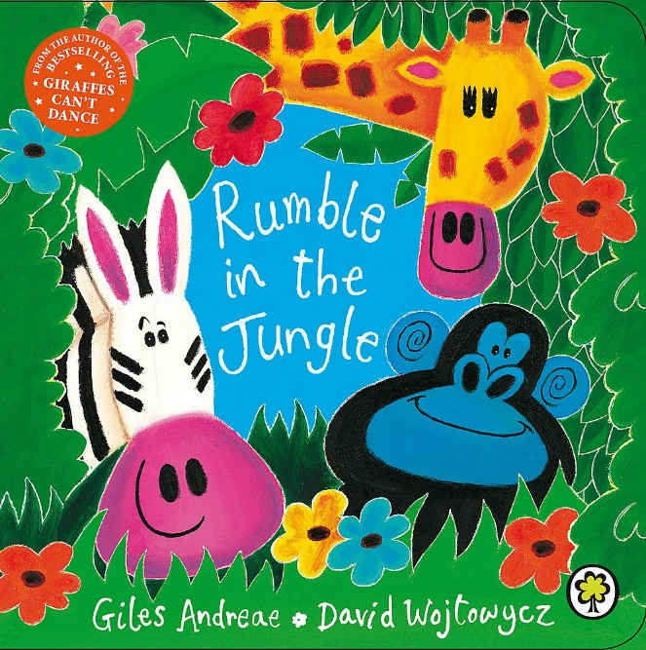

***Learning Journey Overview***

***Poetry – rhyme and rhythm***

|  |  |  |  |  |
| --- | --- | --- | --- | --- |
| **Learning Journey Outcomes** | **Target** | **Some** | **Met** | **Exceed** |
| 1. To apply comprehension skills to answer questions about a poem. |  |  |  |  |
| 1. To identify how many syllables there are in a line of poetry. |  |  |  |  |
| 1. To be able to identify words that rhyme. To be able to include rhyming words in my writing. |  |  |  |  |
| 1. To apply your knowledge of rhyming words to label poetry verses with their rhyming pattern. |  |  |  |  |
| 1. To identify the contractions in the poem. To be able to use contractions in my writing. |  |  |  |  |
| 1. To identify the apostrophes used for possession. To be able to use possessive apostrophes in my writing. |  |  |  |  |
| 1. To identify the exclamation marks used in the poem and understand why they have been used. To be able to use exclamation marks in my writing. |  |  |  |  |
| 1. To compose a verse of poetry that follows a set rhyming pattern. |  |  |  |  |
| 1. To perform a poem using pace and intonation to reflect the rhythm and rhyme of the poem |  |  |  |  |

