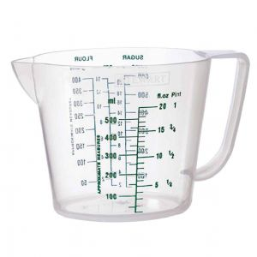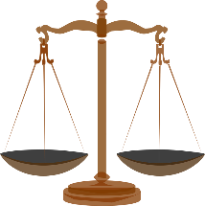

**Learning Journey Overview**

***Year 2***

***Learning Journey Focus:***

***Mass, Capacity & Temperature***

|  |  |  |  |  |
| --- | --- | --- | --- | --- |
| **Key Outcomes of The Learning Journey** |  |  |  |  |
| 1.To compare mass using objects and balance scales (Practical) |  |  |  |  |
| 2. To apply knowledge of comparing mass to read scales and answers questions |  |  |  |  |
| 3. To apply knowledge of grams to read scales and answer questions |  |  |  |  |
| 4. To apply knowledge of kilograms to read scales and answer questions |  |  |  |  |
| 5. To apply knowledge of grams and kilograms to answer a variety of given questions |  |  |  |  |
| 6.Demonstrate how to measure and read in millilitres and litres (Practical) |  |  |  |  |
| 7. To apply knowledge of comparing volume and capacity to answer questions |  |  |  |  |
| 8. To apply knowledge of measuring and reading in millilitres to answer questions |  |  |  |  |
| 9.To apply knowledge of measuring and reading litres to answer questions |  |  |  |  |
| 10 .To apply knowledge of millilitres and litres to answer a variety of given questions. |  |  |  |  |
| 11. To read scales that represent temperature. |  |  |  |  |