**Learning Journey Overview**

***Year 1***

***Learning Journey Focus: Place Value (within 10)***

|  |  |  |  |  |
| --- | --- | --- | --- | --- |
| **Key Outcomes Of The Learning Journey** | **Ongoing Assessment** | | | |
| **Target** | **Some** | **Met** | **Exceeded** |
| * To demonstrate sorting of objects |  |  |  |  |
| * To demonstrate counting of objects |  |  |  |  |
| * To demonstrate counting of objects from a larger group |  |  |  |  |
| * To demonstrate how to represent objects and numbers |  |  |  |  |
| * To recognise numbers as words |  |  |  |  |
| * To demonstrate counting on from any number forwards (0-10) |  |  |  |  |
| * To demonstrate counting one more |  |  |  |  |
| * To demonstrate counting backwards * (0 – 10) |  |  |  |  |
| * To demonstrate counting one less |  |  |  |  |
| * To compare groups by matching (demonstrate one to one correspondence) |  |  |  |  |
| * To demonstrate comparison of numbers of objects (fewer, more, same) |  |  |  |  |
| * To demonstrate comparison of numbers (introduce and utilise <, > and =)   (less than, greater than, equal to) |  |  |  |  |
| * To compare pairs of numbers within 10 |  |  |  |  |
| * To demonstrate how to order objects and numbers |  |  |  |  |
| * To demonstrate how to use and develop a number line (as opposed to a number track) |  |  |  |  |

***Historical Text Learning Journey: WarHorse***

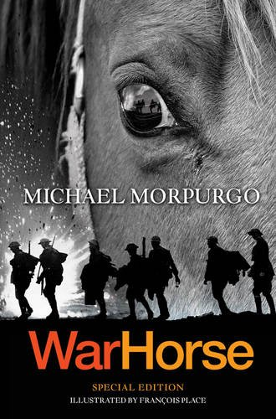

* To summarise main ideas
* To write from a different point of view
* To make inferences about a character
* To predict what will happen
* To create and annotate a freeze frame
* To write a book review
* To compare the book to the film and/or play
* To write a short play script